

Hydrology of   
Jacob’s Well Spring

A tutorial for using HydroDesktop to discover and access water data

August 21, 2012

by:

Dr. Tim Whiteaker ([twhit@mail.utexas.edu](mailto:twhit@mail.utexas.edu))

Center for Research in Water Resources

The University of Texas at Austin

And

Dr. David Tarboton

Utah State University

Distribution

Copyright © 2012, The University of Texas at Austin.

All rights reserved.

Funding

Funding for this document was provided by the Consortium of Universities for the Advancement of Hydrologic Science, Inc. (CUAHSI) under National Science Foundation Grant No. EAR-0622374. In addition, much input and feedback has been received from the CUAHSI Hydrologic Information System development team. Their contribution is acknowledged here.

Table of Contents

Introduction 1

About Jacob’s Well Spring 1

Goals and Objectives 3

Computer and Data Requirements 3

Participating in the Open Source Community 4

Exercise Procedure 5

Getting To Know HydroDesktop 5

Saving a Project 6

Preparing the Map 7

Searching for Hydrologic Data 7

Downloading Data 10

Downloading Additional Data 12

Visualizing Time Series Data 13

Delineating Watersheds 15

Finding Data within a Watershed 16

Exporting Data 18

Advanced: Analysis with R 19

Enabling HydroR 20

Plotting a Graph with R 21

Analyzing Flow in Jacob’s Well Spring 22

Appendix A: R Scripts 25

Script 1: Preparing Inputs for Flow Analysis 25

Script 2: Computing Surface Water Flow Fraction 25

References 27

(this page intentionally left blank)

# Introduction

**CUAHSI-HIS enables sharing of water data**

The Consortium of Universities for the Advancement of Hydrologic Science, Inc. (CUAHSI) Hydrologic Information Systems project (CUAHSI-HIS) has devoted itself to improving access to time series of water data. Towards that end, CUAHSI-HIS has developed standards for sharing data that make it easier to ask for water data and interpret what comes back from a given data source. CUAHSI-HIS also maintains a catalog of data available from organizations that use CUAHSI-HIS standards, essentially serving as a search engine for water data. The result is a universal mechanism for accessing time series data, greatly simplifying the typically laborious task of getting the data you need to do your analysis. But how do people who are unfamiliar with CUAHSI-HIS standards use this system? That’s where HydroDesktop comes in.

**HydroDesktop uses CUAHSI-HIS to help you find water data**

HydroDesktop is a free and open source Geographic Information Systems (GIS) application that helps you discover, use, and manage hydrologic time series data published with CUAHSI-HIS. It handles the details of how to work with CUAHSI-HIS so that you don’t have to. HydroDesktop includes data query, download, visualization, graphing, analysis and modeling capabilities. The result is a spatially-enabled system that facilitates the aggregation of observational data describing the water environment.

**Let’s use HydroDesktop to learn about Jacob’s Well Spring**

This document presents an exercise that shows how to use HydroDesktop to find water data for Jacob’s Well Spring in Texas. With some simple analysis, you will compare characteristics of this groundwater-dominated system with those of a nearby river. During the exercise, you will learn about some of the most commonly-used tools in HydroDesktop.

**Related Links:**

**HydroDesktop -** <http://hydrodesktop.codeplex.com/>

**CUAHSI Hydrologic Information System -** <http://his.cuahsi.org/>

## About Jacob’s Well Spring

The underwater cave known as Jacob’s Well emerges in Hays County, Texas, at Jacob’s Well Spring where it serves as one of the primary sources of water for Cypress Creek, which later flows into the Blanco River. The clear, crisp water cools down many Texans as it moves through the Blue Hole swimming area near Wimberley, Texas. This karst spring has been impacted in recent years by development in Hays County and increasing demands on the Middle Trinity Aquifer (Davidson, 2008).

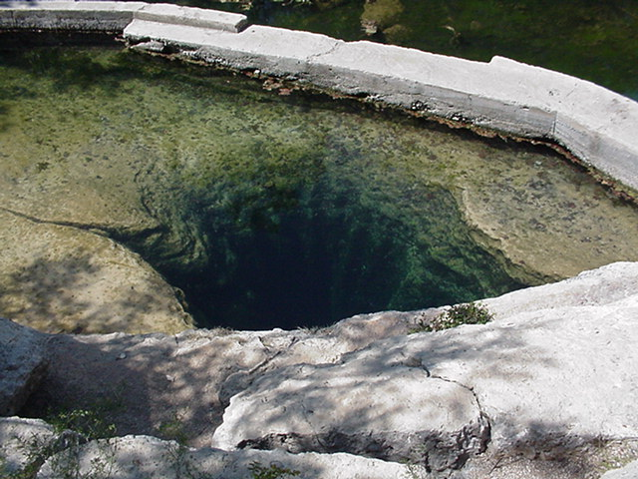

Figure Jacob's Well Spring (San Marcos Local News, 2009)

In 2005, a monitoring station was installed at Jacob’s Well Spring 18 meters below the ground surface, reporting flow and temperature conditions at 15-minute intervals. The data for this station are accessible via the US Geological Survey’s National Water Information System (USGS NWIS).



Figure Cross-sectional diagram of Jacob’s Well (Davidson, 2008)

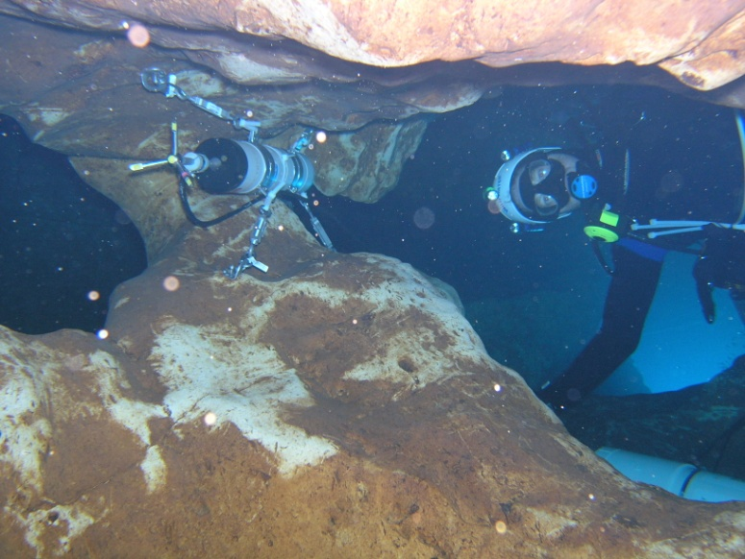

Figure Jacob's Well Spring Monitoring Station (United States Geological Survey, 2007)

For more information about the spring, please read the 2008 Masters thesis of Sarah Cain Davidson from The University of Texas at Austin.

## Goals and Objectives

The goal of this exercise is to introduce you to the tools and functions available in HydroDesktop that allow you to search for and synthesize hydrologic time series data in an area of interest. This exercise will teach you how to find and obtain data for Jacob’s Well Spring in Texas and compare data characteristics using the analysis capabilities of HydroDesktop.

Objectives for this exercise include:

* Find streamflow and temperature data for Jacob’s Well Spring in Texas.
* Identify useful time series and download them.
* Visualize time series data in graphs.
* Export time series data for use in other programs.

## Computer and Data Requirements

HydroDesktop is frequently updated as developers make enhancements to this open source software. The version of HydroDesktop that was used to prepare this exercise is **Version 1.5**. This version is only compatible with a Windows operating system such as **Windows 7**. You will also need an Internet connection since you will be accessing online resources to download time series data.

**To install HydroDesktop:**

1. In a Web browser,navigate to <http://hydrodesktop.codeplex.com/>.
2. Click the **Downloads** link near the top left of the page.
3. If the current page is not for the 1.5 Recommended Release, find the link for the **1.5 Recommended Release** on the right and click it.
4. Find the link for the installer (e.g., HydroDesktop_Installer_1.5.3.2.exe) and click it.
5. Save and run the installer, accepting all defaults. The installer will guide you through the rest.

An advanced portion of the exercise involves using the R statistical package within HydroDesktop. R is a separate program from HydroDesktop, so you will need to install it if it is not already installed on your computer. It is not included with the HydroDesktop installation.

**To install R:**

1. In a Web browser, navigate to [**http://www.r-project.org/**](http://www.r-project.org/).
2. Click the **download R** link.
3. Click the link for a download site near your current location.
4. Click the link for your operating system (most likely Windows if you are using HydroDesktop).
5. Click the link for the **base** installation.
6. Click the link to **Download R**.
7. Run the setup file and follow the instructions to complete the installation.

## Participating in the Open Source Community

HydroDesktop is an open source product, which means that anyone can see the source code used to create the program and contribute to its development. Even if you aren’t a programmer, you can still participate in the discussion forums and post bugs or feature requests in the issue tracker.

The home for HydroDesktop is on CodePlex, a website for open source software. To add to the discussions or post a bug, you must first register for your free CodePlex account. Once you have a CodePlex account, you can log in at <http://hydrodesktop.codeplex.com/> and start contributing. The community is really what drives open source software development, so this is an exciting opportunity to make your voice heard.

You are encouraged to provide feedback on any issue or problem you may encounter throughout this exercise. Feel free to utilize online resources such as the issue tracker on the HydroDesktop website when providing feedback. In this exercise you’ll learn how to access these resources directly through HydroDesktop.

# Exercise Procedure

Suppose you live in Hays County in Texas, and for years you have enjoyed taking a dip in the Blue Hole swimming area along Cypress Creek during hot Texas summers. As population growth and increased groundwater pumping threaten Jacob’s Well Spring, the primary source of water for Cypress Creek, you decide to learn more about this valuable resource. In this exercise, you’ll use HydroDesktop to find temperature data and see how it compares to a nearby river.

## ****Getting To Know HydroDesktop****

Let’s open HydroDesktop and get to know its user interface.

1. Open **HydroDesktop**.
2. Choose to create a new **North America** project and click **OK**.

Take a moment to explore the user interface. As you can see, HydroDesktop looks much like a typical GIS interface. It supports complex layer symbologies, access to online map services, and custom programmed tools and plugins. It even comes with some basemap shapefile data which are already added to the map. What sets HydroDesktop apart from other GIS applications, is the ability to query for hydrologic time series data.

Notice that HydroDesktop presents many of its controls on a ribbon, much like modern versions of Microsoft Office. The ribbon is organized into tabs which contain groups of buttons and tools.

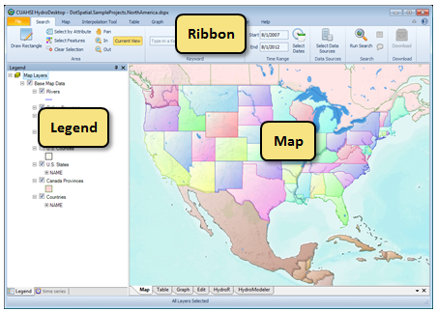

Figure HydroDesktop User Interface

If you have comments or issues as you work through this exercise, you can find helpful resources on the Help tab. The buttons on this tab let you view documentation, jump to the discussion forums or issue tracker, email for help, or submit a comment.

1. Click the **Help** tab in the ribbon to view the buttons available on that tab.
2. Click the **Issues** button to open the issue tracker on the HydroDesktop website.

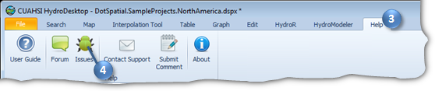

Figure Using the Help Tab To Open the Issue Tracker

1. Close the Issue Tracker Web page.

## Saving a Project

HydroDesktop manages your work within *projects*. A HydroDesktop project file (.hdprj) contains information about what geospatial layers you have in your map and how those layers are symbolized. The data behind these layers are often stored in shapefiles, a widely available GIS data format. Shapefiles of basemap data such as state boundaries are included with HydroDesktop and are typically saved in the same location as the HydroDesktop project file.

The project file also connects your work to a database (.sqlite file) where temporal data are stored. This is where the time series data that you download through HydroDesktop are saved. A relational database is more efficient at storing time series data than shapefiles, and HydroDesktop uses a free database called SQLite for this purpose.

You can create projects to organize your work, and you can save the project so that you can open it again later. When you first open HydroDesktop, it sets up a clean map and loads a default database. In order to better manage the work in this exercise, you will give this project a name and save it somewhere meaningful to you.

**To save the project and database:**

1. In the **File** menu, click **Save As**.
2. Choose a location to save your project such as your desktop. The author recommends creating a folder in which the project file will be saved because other data such as the time series database and shapefiles will also be stored here.
3. Name the project **springs** and then click **Save**.

The text in the title bar of the HydroDesktop window should now include the name of your project. HydroDesktop has also created a database for your project named “springs.sqlilte.” This database is saved in the same location as your project file. You are now ready to work within your newly saved project and database.

## Preparing the Map

HydroDesktop includes basemap layers such as state and county boundaries to help you define your study area. You can also add your own data such as a shapefile of your study area using the **Add Layer** button on the **Map** tab.

Another neat feature of HydroDesktop is the ability to consume online basemaps. These are maps cached at multiple scales provided by the likes of ESRI, Google, and OpenStreetMap, which provide a rich cartographic representation for the earth without having to download the underlying data (terabytes) to your local computer.

An online basemap was probably already selected for your project by default. You can easily select a different basemap using the following procedure.

**To select an online basemap:**

1. On the **Map** tab, in the **Online Basemap** panel, choose a basemap such as **ESRI World Topo**.
2. In the **Online Basemap** panel, set the **Opacity** of the basemap to **50**. This allows map layers which appear underneath the online basemap (as ordered in the Legend) to show through.
3. In the **Legend**, uncheck the **U.S. States** layer to hide that layer.

These online basemaps, the shapefiles included with HydroDesktop, and your own shapefiles all help you to locate the area of interest for your project.

## Searching for Hydrologic Data

When searching for data in HydroDesktop, you can specify the following filters: area of interest, parameter keywords, time range, and data sources. HydroDesktop then searches the CUAHSI-HIS national catalog of known time series data to find locations of time series that match your search. Search results are presented in the map and include information that HydroDesktop can use to connect to each individual data provider for data access. You can further filter the results and then choose which data you want to actually download and store in your database.

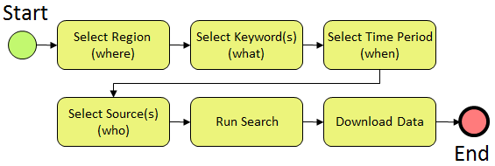

Figure Workflow for Accessing Hydrologic Data

This workflow is initiated using the Search tab of the HydroDesktop ribbon (Figure 7). The panels in this tab are arranged in the same order as the workflow above.

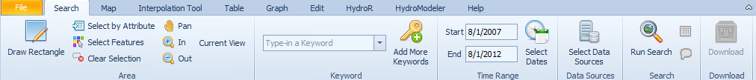

Figure Search Tab

In this exercise, you will locate streamflow and temperature data for one water year near Jacob’s Well Spring. The county boundary for Hays County is included in the U.S. Counties layer that is already in the map. You’ll use this boundary to restrict the area being searched.

**To search for streamflow in Hays County:**

1. In the ribbon, click the **Search** tab.
2. Select Hays County as the area of interest.
   1. In the **Area** panel on the ribbon, click **Select by Attribute**.
   2. Select **U.S. Counties** as the active layer. The default field of NAME will suffice.
   3. Select **Hays, TX**, from the list of county names. You can click in the list and start typing “Hays” to quickly find the item you’re looking for.
   4. Click **OK**.

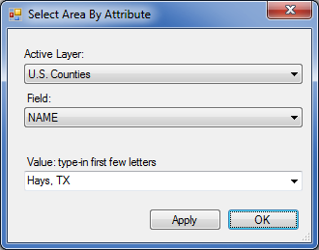

Figure Choosing a Search Area

Next you will tell HydroDesktop what hydrologic variables you want. To help you in this regard, HydroDesktop employs a list of official CUAHSI-HIS keywords for hydrologic variables. Data providers use this list when registering their data with CUAHSI-HIS. This makes it a lot easier for you to find the variable you want, rather than typing whatever term the data provider may be using internally (e.g., 00060 for USGS streamflow).

1. In the box within the **Keyword** panel on the ribbon, type **Streamflow**. The box autocompletes to a valid search term from the list of parameter keywords that CUAHSI maintains.

Next you will tell HydroDesktop the date range of time series that you want. For this exercise, search for data available in the 2010 water year, i.e., 10/1/2009 to 9/30/2010.

1. In the **Time Range** panel, change the start date and end date to **10/1/2009** and **9/30/2010**, respectively.

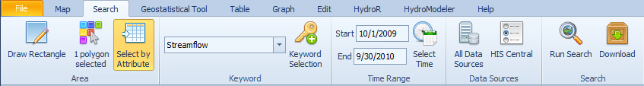

Figure The Search tab displays your search criteria as you enter them

At this point you could click in the Data Sources panel to restrict the search to specific data sources, but for this portion of the exercise you will search all data sources, which is the default setting. With search parameters set, you will now tell HydroDesktop to run the search for data.

1. In the **Search** panel, click **Run Search**.
2. Once the search has completed, close the progress dialog.

When you run a search, HydroDesktop makes a connection to the CUAHSI-HIS national catalog to ask for descriptions of time series that match your search criteria. After HydroDesktop has finished searching for time series, it displays the locations of time series that fit your search criteria in a map layer called Data Sites. Different symbols for the sites indicate different data sources. You can see a label for the Jacob’s Well Spring site in the map.

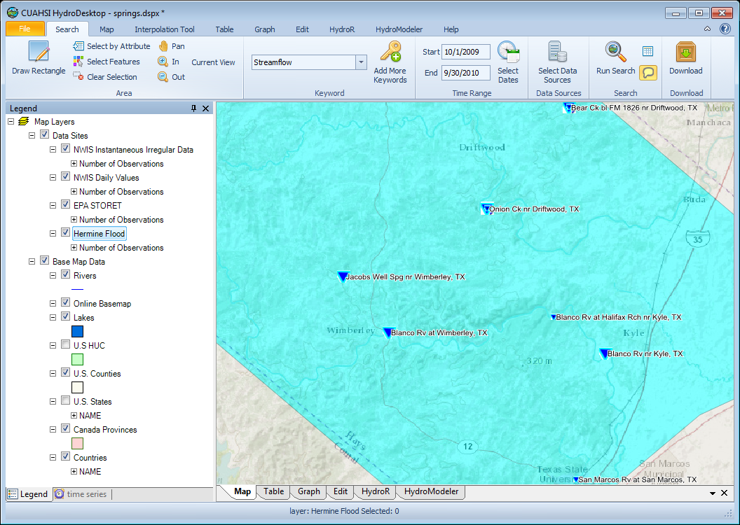

Figure Locations of Streamflow in Hays County

While the search may have seemed fast, remember that your map is only showing where time series of interest are located, and that you haven’t actually downloaded any time series values yet. Now you can begin to refine these search results to locate time series that you actually want to download and save to your database.

## Downloading Data

For this exercise, you will work with streamflow at the following two sites:

* Jacobs Well Spg nr Wimberley, TX
* Blanco Rv nr Kyle, TX (a site near Jacob’s Well Spring for comparison)

You will select the features that represent these time series so that HydroDesktop knows which time series you want to download. While several data sources were returned from the search, in this exercise you will only download streamflow from the USGS National Water Information System Daily Statistics archive (NWIS Daily Values).

**To select time series for download:**

1. In the **Legend** on the left, uncheck **NWIS Instantaneous Irregular Data**, **EPA STORET**, and **Hermine Flood** to hide those layers. The only layer you will work with is the NWIS Daily Values layer.
2. Right-click the **NWIS Daily Values** layer name and click **View** **Attribute Table**.

The table opens in a dockable window showing you descriptions of time series in this layer. You can scroll through the table and resize columns to see the information. You can also type in the first row for a given field to search for data that match what you typed. The NWIS Daily Values service includes statistics of average, minimum, and maximum daily values. You’ll just be working with average values in this exercise.

1. In the **Attribute Table**, scroll to the right to fine the **Data Type** field. In the blank row below the field name, type the letter **a** to filter the list to show only time series of average values (i.e., records whose data type begins with the letter “A”).
2. Scroll to the left to see site names. While holding down the CTRL key, left-click on one row for **Jacob’s Well Spring** and another row for the **Blanco River near Kyle**.

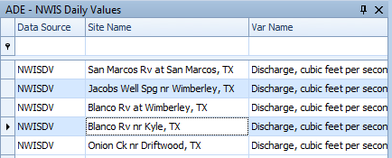

Figure Selecting Time Series for Download

1. Click the small x in the top right corner of the attribute table to close it.

With these rows selected, you are ready to download the data.

1. In the ribbon, in the **Search** panel, click **Download**. The Download Manager opens to show progress of the download.

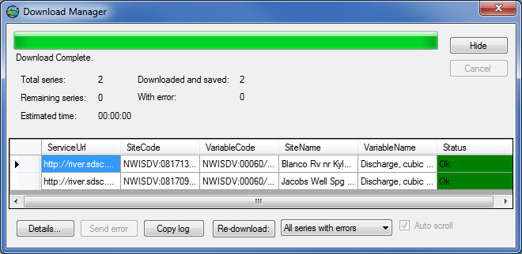

Figure Download Manager

1. Close the Download Manager when the download is complete.

**Tip**If a download fails, you can right-click the failed row in the Download Manager to attempt the download again.

## Downloading Additional Data

You might be excited about viewing your downloaded data, but before you do, let’s retrieve some water temperature data for Jacob’s Well Spring. Since you retrieved data from NWIS Daily Values in the previous search, you will restrict this new search so that NWIS Daily Values is the only data source that is queried.

**To search for and download water temperature data:**

1. In the ribbon, in the **Keyword** panel, enter **Water temperature**.
2. Restrict the search to NWIS Daily Values.
   1. In the **Data Sources** panel, click **Select Data Sources**.
   2. In the Data Sources dialog, click **Select None**.
   3. In the list of data sources, find and place a check next to **NWIS Daily Values**.
   4. Click **OK** to close the Data Sources dialog.

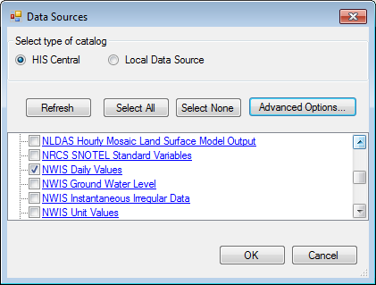

Figure Choosing Data Sources

**Tip**You can click the name of a data source in the Data Sources dialog to open a Web page with more information about that source.

1. In the **Search** panel, click **Run Search**.
2. Once the search has completed, close the progress dialog.

An NWIS Daily Values (2) layer is added to the map legend to show results from this second search.

1. In the **Legend** on the left, right-click the **NWIS Daily Values (2)** layer name and click **View** **Attribute Table**.
2. In the **Attribute Table**, type the letter **a** below the **Data Type** field to show only time series of average values.
3. Scroll to the left to see site names. While holding down the CTRL key, left-click on one row for **Jacob’s Well Spring** and another row for the **Blanco River at Halifax Ranch**.
4. Click the small x in the top right corner of the attribute table to close it.
5. In the ribbon, in the **Search** panel, click **Download**.
6. Close the Download Manager when the download is complete.

Now that you’ve downloaded the data, you can view the data in both tabular and graph form.

## Visualizing Time Series Data

HydroDesktop takes a series-centric view of temporal data, meaning that it provides access to the data at the time series level. An example of a time series is all of the temperature values measured at a certain point on the Blanco River. Let’s take a look at the time series that you just downloaded.

**To visualize time series data in HydroDesktop:**

1. Click the **Graph** tab in the ribbon to activate it.

On the left you will see a list of all the time series in your database. You could use filters to restrict the time series that are shown, but you only retrieved a handful in this exercise so it’s fine to leave the default view.

1. In the list of time series on the left, place a check next to temperature at the Blanco River at Halifax Ranch.

From the graph you can see how the temperature in the water changes with the seasons throughout the year. Now let’s compare this time series with the one for Jacob’s Well Spring.

1. Place a check next totemperature at Jacob’s Well Spring.

HydroDesktop allows you to visualize multiple time series on the same graph. The plot axes automatically adjust to fit your data. In this example, there is a dramatic difference between the two temperature time series. The one for Jacob’s Well Spring shows much less variation throughout the year than the one for the Blanco River at Halifax Ranch.

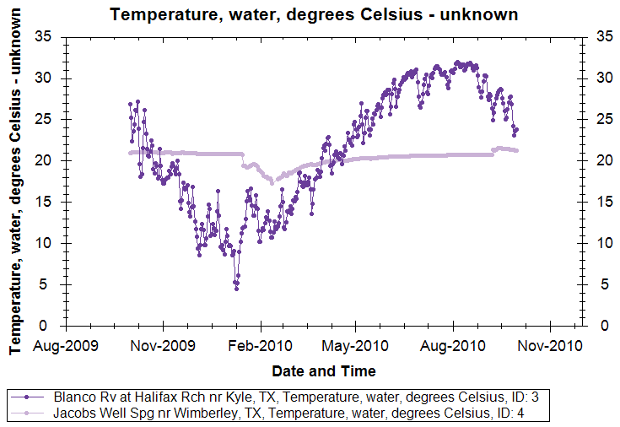

Figure Comparing Temperature Time Series

1. In the ribbon, click **Probability** to show a probability plot of the data, further illustrating the difference between the two time series.
2. Click **TimeSeries** to restore the time series view.

The dramatic difference in the shapes of the two time series plots is caused by the source of water for these two rivers. The Blanco River at Halifax Ranch is largely a surface water system while Jacob’s Well Spring is fueled by groundwater. While the groundwater system does maintain a much more steady temperature than the surface water system, notice how sharp changes still exist, such as the sudden decrease in temperature in mid-January, 2010. Let’s plot flow on this graph to see why this might be happening.

1. Place a check next to **Discharge at Jacob’s Well Spring**.

Notice the increase in streamflow around the same time that the water temperature dropped. It seems like the system is experiencing a large influx of surface water, which is colder than the groundwater in the winter. Similarly, you can see an increase in streamflow in late summer, 2010, which results in an increase in water temperature.

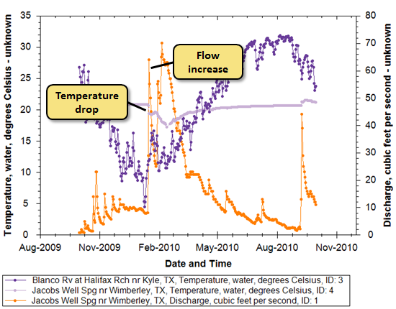

Figure Examining Changes in Flow and Temperature

1. Uncheck the two temperature time series, and place a check next to **Discharge at the Blanco River near Kyle**.

The flow of the Blanco River dwarfs that of Jacob’s Well Spring, but you can still see increases in flow in the Blanco River at about the same time as those observed in the spring. Also notice the peak flow in September, 2010. This flow is the result of tropical storm Hermine as it swept through Texas.

## Delineating Watersheds

At this point, it might be nice to see precipitation data in this watershed for this water year. You can delineate watersheds for any river in the conterminous U.S. using a Web service provided by the EPA. All you have to do is click on the desired watershed outlet location in the map, and then HydroDesktop sends that point location to the EPA service. The service figures out which National Hydrography Dataset (NHD) reach the clicked point is closest to, and then finds all catchments that the reach drains. The catchments are merged into a single watershed and returned to HydroDesktop.

Note that the watershed returned is for the outlet of the entire reach, so if the point you clicked isn’t at the reach outlet, then the resulting watershed will include some additional area downstream of your clicked point. Thus, this tool is useful for helping to identify an area of interest but should not be used to determine watershed parameters such as area. Future versions of the tool will support more precise delineation.

In this portion of the exercise you will delineate a watershed for the area draining to Jacob’s Well Spring. The watershed delineation tool is part of a HydroDesktop extension called EPA Delineation.

**To delineate a watershed for the area draining approximately to the Jacob’s Well Spring location:**

1. On the **Map** tab, in the **Zoom** panel, activate the (zoom) **In** tool. Draw a box around the site at Jacob’s Well Spring to zoom in to it a bit. This helps ensure that you click exactly at the spring outlet.
2. In the **Legend**, uncheck **U.S. Counties** to hide that layer.
3. In the **EPA Tool** panel, click **Delineate** to activate the delineation tool.
4. The tool prompts you for where to save the resulting datasets. Accept the defaults by clicking **OK**.
5. Click on the site location for Jacob’s Well Spring.

After a moment, the watershed is shown in the map. The NHD reaches flowing to the point that you clicked and the point itself are also shown.

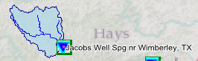

Figure Delineated Watershed

**Tip**  
You can use the scroll wheel on your mouse to zoom in and out.

If you didn’t get the correct watershed delineated then you can activate the tool and try again. It’s OK to overwrite previous results.

**Note**Recall that the watershed is actually delineated for the outlet of the nearest NHD reach, which happens to be very close to Jacob’s Well Spring in this example. Also be aware that the surface watershed you just delineated defines some but not all of the area contributing water to the aquifer for Jacob’s Well Spring. However, the area will suffice for this exercise which merely demonstrates how to delineate watersheds and use those watersheds to find data.

Now you’re ready to search for data in this watershed.

## Finding Data within a Watershed

Now you’ll search for daily precipitation data from the National Weather Service (NWS) in the watershed for Jacob’s Well Spring.

1. In the ribbon, click the **Search** tab.
2. Choose the delineated watershed as the area of interest.
   1. In the **Area** panel on the ribbon, click **Select by Attribute**.
   2. Select **Watershed** as the active layer. The default field of Id will suffice.
   3. Select the only value present, which is probably a value of 1.
   4. Click **OK**.
3. In the **Keyword** panel, enter **Precipitation**.
4. Restrict the search to the NWS West Gulf River Forecast Center’s (WGRFC) multi-sensor precipitation estimates.
   1. In the **Data Sources** panel, click **Select Data Sources**.
   2. In the Data Sources dialog, click **Select None**.
   3. In the list of data sources, find and place a check next **NWS-WGRFC Daily Multi-sensor Precipitation Estimates**.
   4. Click **OK** to close the Data Sources dialog.
5. In the **Search** panel, click **Run Search**.
6. Once the search has completed, close the progress dialog.

When the search finishes, you’ll see some regularly-spaced dots over the watershed. These dots represent the centroids of NEXRAD HRAP cells. In other words, this Web service provides discrete point locations where you can basically sample this gridded rainfall dataset. Each of these points is like a virtual rain gauge. For this exercise, you’ll just pick one near Jacob’s Well Spring.

In addition to choosing time series from the Attribute Table as you have already done in this exercise, you can also hover your mouse over a site and download time series from the pop-up bubble that appears.

1. Hover your mouse over one of the precipitation sites.
2. In the pop-up bubble that appears, click **Download data**.

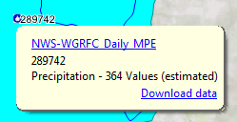

Figure Pop-ups summarize time series available at a given location

1. Close the Download Manager when the download is complete.

The precipitation data are added to your database. Now let’s view the results.

1. Click the **Graph** tab.
2. Plot a graph with the **precipitation** time series you just downloaded and **Streamflow from Jacob’s Well Spring**. Notice how quickly Jacob’s Well Spring responds to rainfall events.

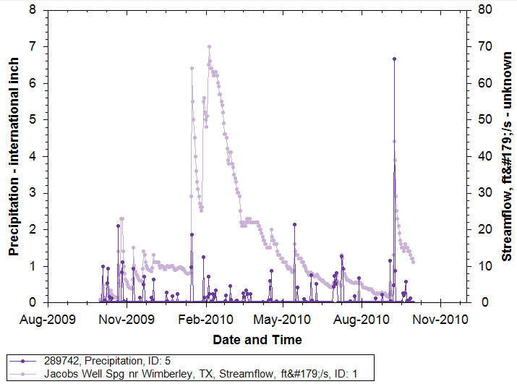

Figure Precipitation and Streamflow at Jacob's Well Spring

While HydroDesktop does contain additional analysis capabilities, it can also export data to a text file for use in other programs.

## Exporting Data

HydroDesktop can export data to a variety of output file types for further study and analysis. For example, you can export individual time series by right-clicking them in Table or Graph view. For this exercise, you will export all time series that you have downloaded.

**To export time series data:**

1. Click the **Table** tab in the ribbon to activate it.
2. In the **Data Export** panel, click **Export**.

This tool exports data to a delimited text file. In the Export To Text File dialog, notice that the time series are organized into themes. Each theme corresponds to a given data source and search parameter. You can choose which themes to export. You can also control the fields that are included in the export and choose a delimiter. For this exercise, you will accept all defaults to produce a comma delimited text file.

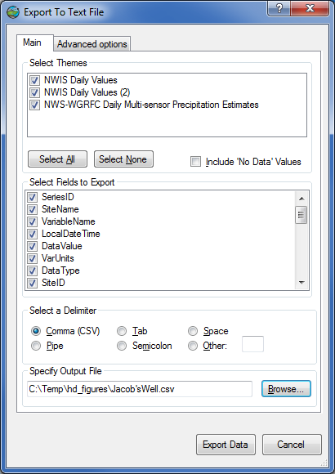

Figure Export To Text File Dialog

1. In the **Export To Text File** dialog, specify the output file location and name.
2. Click **Export Data.**
3. Close the **Export To Text File** dialog when it is finished.
4. Find the file on your computer and open it to verify that the data were exported.

Congratulations! With your data in hand, you have completed the exercise and learned how to use HydroDesktop to discover and access water data. Feel free to experiment with other functionality such as creating and printing a map, and be sure to give feedback using the Help tab. This concludes the main portion of the exercise. For an example of more advanced analysis, continue with the section below to learn how to use the R statistical environment with HydroDesktop.

# Advanced: Analysis with R

The work above has illustrated how to download temperature, precipitation and discharge data and suggested that variations in temperature in Jacob's Well Spring may be related to the mixing of surface and subsurface water sources. In this section, you will use the HydroR plug-in in HydroDesktop to explore this phenomenon. The HydroR plug-in provides an interface between HydroDesktop and the free R statistical software environment.

## Enabling HydroR

Once R is installed, you will need to enable HydroR in HydroDesktop.

**To enable HydroR:**

1. Click the **HydroR** tab in the ribbon.
2. In the **HydroR Tools** panel, click **Start R**.
3. If prompted for the path to R.exe, enter the path where it was installed on your computer. Note that R may include more than one R.exe file. The one you typically need is in the **bin\i386\** folder, as in C:\Program Files\R\R-2.13.0\bin\i386\R.exe. Click **OK** once the path is entered. HydroDesktop will remember this path the next time you use the HydroR extension.
4. HydroDesktop needs some additional R libraries. If you are using the HydroR extension for the first time, you may be prompted for a CRAN mirror to download these libraries. Select the mirror closest to your location and click **OK**. The appropriate libraries are downloaded automatically.

R should now start and give you a blank R script in the top panel and R Console in the bottom panel. Standard R commands can be entered in the R Console. HydroR makes it easy to provide R access to the data you have downloaded with HydroDesktop using the HydroR tab.

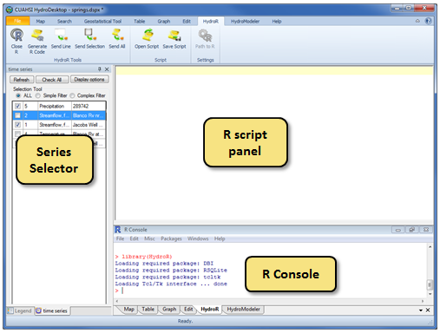

Figure HydroR Layout

## Plotting a Graph with R

To get familiar with how HydroR works, you’ll plot a hydrograph for Jacob’s Well Spring.

**To plot a graph in HydroR:**

1. In the **HydroR** tab, in the list of time series on the left, select a time series that you would like to import as a data frame into R. For this exercise, select **streamflow at Jacob’s Well Spring**. Make sure no other time series are selected.
2. In the ribbon, click **Generate R code**. The R code to get the selected data series is entered into the script.
3. Click **Send All**. This sends the script text to the console and executes it. The result is an object named **data0**, which contains a list of R data frames.
4. In the **R Console**, enter **labels(data0)** to see a list of data frames that make up data0.

These data frames are basically tables from your HydroDesktop database. The key table we’re interested in for this exercise is the DataValues table.

1. To see the first few rows of DataValues, in the **R Console**, enter **head(data0$DataValues)** (R is case sensitive, so type the command exactly as it appears in this text). You may have to scroll up in the R Console to see the full result.

You’ll use the LocalDateTime and DataValue columns to provide data for the graph.

1. To make it easier to access this streamflow time series, in the **R Console**, enter **Q.jacobs=data0$DataValues**. This assigns the DataValues data frame to a variable named **Q.jacobs**.
2. In the **R Console**, enter **plot(Q.jacobs$LocalDateTime,Q.jacobs$DataValue,type="l")** (the type is a lower case L, not a one). A time series plot of the data should appear in an R graphics window, demonstrating that the full capability of R is available to work with the data that has been imported.

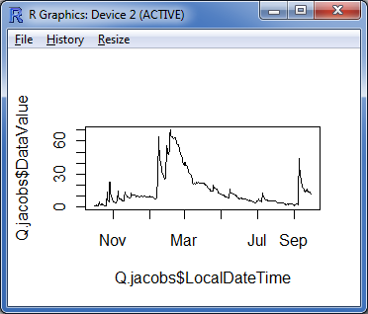

Figure Jacob’s Well Spring Hydrograph Plotted Using R

Let’s add a title to this graph.

1. In the **R Console**, enter **data0$Variable** to see all attributes for the Variable table.
2. In the **R Console**, enter **title(data0$Variable$VariableName)** to add the variable name as the title for the plot.
3. After verifying that the title was added, close the R graphics window showing the graph.

## Analyzing Flow in Jacob’s Well Spring

Let's use mixing theory to estimate the fractions of Jacob's Well Spring flow that are from the surface and subsurface based on temperature. Assume the surface source has temperature equal to the temperature in Blanco River. Assume groundwater source is at a fixed temperature. The following equations then apply.

Energy Balance: QT=Q1T1+Q2T2

Mass Balance: Q=Q1+Q2

where Q is discharge in Jacob's Well Spring, T is Temperature in Jacob’s Well Spring, T1 is the temperature of the surface source (assumed equal to Blanco River temperature), and T2 is the temperature of the subsurface source (assumed constant and taken as the average of last 60 days). Q1 and Q2 are the unknown discharge contributions from surface and subsurface sources respectively (Figure 22).

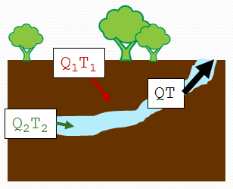

Figure Surface and subsurface contributions to Jacob's Well Spring outflow and temperature

Two linear equations, two unknowns can be easily solved (see your high school algebra book). The solution is

Q1/Q = (T-T2)/(T1-T2)

The R scripts in Appendix A use data from HydroDesktop to solve this equation. You’ll assign the relevant time series to simple variable names and then use the R scripts to plot a graph representing the amount of flow in Jacob’s Well Spring inferred as coming from the surface.

**To use the R scripts to compute fractional flow:**

1. In the same manner that you created the Q.jacobs variable above and assigned it to be the discharge at Jacob’s Well Spring, create and assign the following R variables (remember, the variable names are case sensitive). In other words, for each variable, clear the R script panel, select a series, generate the R code, send it to R, and assign the variable in the R Console.
   1. Q.blanco – Discharge at the Blanco River near Kyle
   2. t.blanco – Water temperature at the Blanco River at Halifax Ranch
   3. t.jacobs – Water temperature at Jacob’s Well Spring**

**\*\*IMPORTANT**  
You may encounter a bug when generating R code for water temperature at Jacob’s Well Spring. In the R script panel, if the endDate is not “2010-09-30” then edit the script to use “2010-09-30” before sending the script to the R Console.

1. Enter **Script 1** found in Appendix A into the **R Console** to execute the script. This script prepares inputs for the analysis and plots graphs of the input temperature and flow.
2. Once you have reviewed the graphs of temperature and streamflow generated by Script 1, close the two R Graphics Windows containing the graphs.
3. Enter **Script 2** found in Appendix A into the **R Console** to execute the script. This script smooths the temperature time series and then performs the analysis to determine the fraction of flow in Jacob’s Well Spring from surface water.

The resulting graphs show smoothed temperature time series and the portion of flow in Jacob’s Well Spring inferred to be from the surface (the red line in the graph). Note that the analysis requires differences between the assumed groundwater temperature and surface water temperature, so the graph will be missing segments when those temperatures are nearly the same.

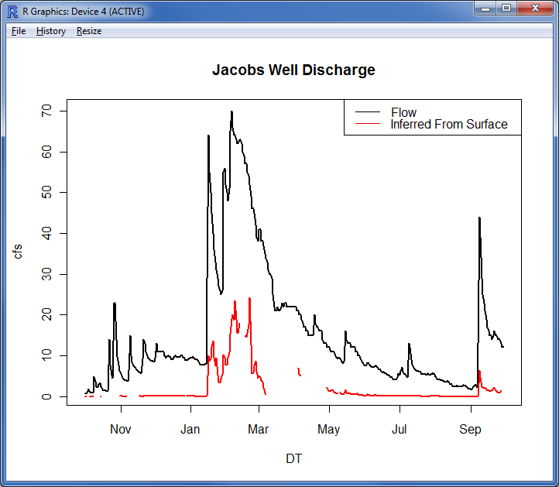

Figure Fractional Flow in Jacob's Well Spring

Congratulations! You have completed the exercise and seen how advanced analysis environments such as R can be integrated into HydroDesktop using the power of plug-ins. This concludes the advanced portion of the exercise.

# Appendix A: R Scripts

## Script 1: Preparing Inputs for Flow Analysis

# SCRIPT 1: PREPARING INPUTS FOR FLOW ANALYSIS

# This code plots input time series of flow and temperature.

# The code assumes the following variables have already been set to

# the DataValues data frame for these time series:

# Q.jacobs - Discharge at Jacob's Well Spring

# Q.blanco – Discharge at the Blanco River near Kyle

# t.jacobs – Water temperature at Jacob’s Well Spring

# t.blanco – Water temperature at the Blanco River at Halifax Ranch

# The code handles intermittent missing values

# Start one day earlier because queries seem to be based on UTC

DT = seq(from=as.Date("2009-09-30"),to=as.Date("2010-09-30"),by=1)

ind=match(as.Date(t.blanco$LocalDateTime,"%Y-%m-%d %H:%M:%S"), DT)

T1=rep(NA,length(DT))

T1[ind]= t.blanco$DataValue

ind=match(as.Date(t.jacobs$LocalDateTime,"%Y-%m-%d %H:%M:%S"), DT)

T=rep(NA,length(DT))

T[ind]=t.jacobs$DataValue

T2 = T[1] # The first value

ind=match(as.Date(Q.jacobs$LocalDateTime,"%Y-%m-%d %H:%M:%S"), DT)

Q=rep(NA,length(DT))

Q[ind] = Q.jacobs$DataValue

plot(DT,T1,type="l",ylab="T")

lines(DT,T,col=2)

legend("bottomright",c("T Blanco","T Jacobs"),col=c(1,2),lty=1)

windows()

plot(DT,Q,type="l")

## Script 2: Computing Surface Water Flow Fraction

# SCRIPT 2: COMPUTING SURFACE WATER FLOW FRACTION

# This script solves the equation Q1/Q = (T-T2)/(T1-T2)

# and plots a graph showing the portion of flow inferred

# to be directly from surface water sources in Jacob’s

# Well Spring.

# Before running this script, you must run SCRIPT 1:

# PREPARING INPUTS FOR FLOW ANALYSIS

# Smoothing Blanco River temperature data using lowess

ind=!is.na(T1) # array indices of unmissing values

T1l<-lowess(DT[ind],T1[ind],f=0.1)

plot(DT,T1,type="l",ylab="Degrees C")

lines(T1l,col=2)

lines(DT,T,col=3)

legend("bottomright",c("Blanco T","Smoothed Blanco T","Jacobs T"),col=c(1:3),lty=1)

title("Temperatures")

# Match the dates of the output for use in calculations

ind=match(T1l$x,DT)

T1s=rep(NA,length(DT))

T1s[ind]=T1l$y

# For results to be reasonable T1 and T2 have to be different.

# Only evaluate answers when T1 and T2 differ by at least 3 degrees

# Also only accept positive answers

# Calculate T2 as average over last 60 days

T2p=c(rep(T[1],59),T)

T2=rep(NA,length(DT))

for(i in 1:length(DT)) T2[i]=mean(T2p[i:(i+59)],na.rm="True")

Q1f=(T-T2)/(T1-T2) # apply the mixing solution equation

# eliminate answers when temperature difference is less than 3

indna=abs(T1-T2)<3

Q1f[indna]=NA

indna=Q1f< -0.05 # eliminate large negative values

Q1f[indna]=NA

# Plot the results

windows()

plot(DT,Q,type="l",ylab="cfs",lwd=2)

lines(DT,Q*Q1f,col=2,lwd=2)

legend("topright",c("Flow","Inferred From Surface"),lty=1,col=c(1,2))

title("Jacobs Well Discharge")

# References

Davidson, S. C. (2008). *Hydrogeological characterization of baseflow to Jacob’s Well spring, Hays County, Texas* (Master’s thesis). Retrieved November 2, 2010, from Hays Trinity Groundwater Conservation District website: <http://haysgroundwater.com/files/Documents/Davidson-08_thesis_Cypress_Crk_Jacobs_Well.pdf>.

San Marcos Local News. (2009, March 10). Jacobs Well area to hold incorporation vote. Retrieved November 2, 2010, from San Marcos Local News website: <http://www.newstreamz.com/2009/03/10/area-around-jacobs-well-to-hold-incorporation-election/>.

United States Geological Survey. (2007, March 26). National Surface Water Conference and Hydroacoustics Workshop. Retrieved November 1, 2010, from United States Geological Survey website: <http://water.usgs.gov/osw/images/2007_photos/Hydroacoustics.html>.